Strand 4 – Enzymes

Science students conducted an investigation to determine how enzymes affect apple juice production.

Procedure:
- Place coffee filter in paper cone; cut off 2 cm of the bottom of the cone, leaving a small hole.
- Place 30 ml of apple sauce into measuring cup, add 5 drops of enzyme A solution, and stir thoroughly.
- Place a graduated cylinder under paper cone and add apple sauce to coffee filter, stirring every minute.
- Measure volume of apple juice in cup after 5 minutes using graduated cylinder.
- Repeat steps 1-4 for a second trial.
- Repeat steps 1-5 using enzyme B solution.
- Repeat steps 1-5 using water.

Amount of Juice Produced
Enzyme Solution | Trial 1 (ml) | Trial 2 (ml) | Average (ml)
A | 14 | 15 | 14.5
B | 6 | 5 | 5.5
Water | 5 | 5 | 5.0

- Identify two variables that were held constant in the group’s experiment.
- Explain why it is important for these variables to be held constant.

Rubric for Enzymes

Possible Correct Responses:

• the amount of apple sauce used in measuring cup for each trial
• the number of drops of each enzyme used in each trial (volume)
• the stirring of the apple sauce (done every minute)
• the amount of time enzyme is allowed to act before measuring apple juice
• the cut off of 2 cm of the bottom of the cone allowing the apple juice to drain

If any of these factors are not controlled, they could affect the results preventing the students from
drawing a valid conclusion.

If the students were to test more than one variable at a time, they would not be able to tell which variable is responsible for the results or if it was a combination of both.

3-Point Rubric:

Score 3
The response clearly identifies two specific variables that were held constant and provides an
explanation that addresses the validity of the results in terms of testing too many variables at once.

Score 2
The response clearly identifies two variables that were held constant but fails to provide a clear
explanation of why it is important to hold these variables constant.
-or-
The response clearly identifies one variable that was held constant and provides an explanation that
addresses the validity of the results in terms of testing too many variables at once.

Score 1
The response clearly identifies one variable that was held constant but fails to provide a clear
explanation of why it is important to hold this variable constant.
-or-
The response provides a clear explanation of why it is important to hold variables constant without
clearly identifying any of the variables that were held constant.

Score 0
The response provides little or no accurate or relevant information.

Sample Student Responses

Response #1 (3)
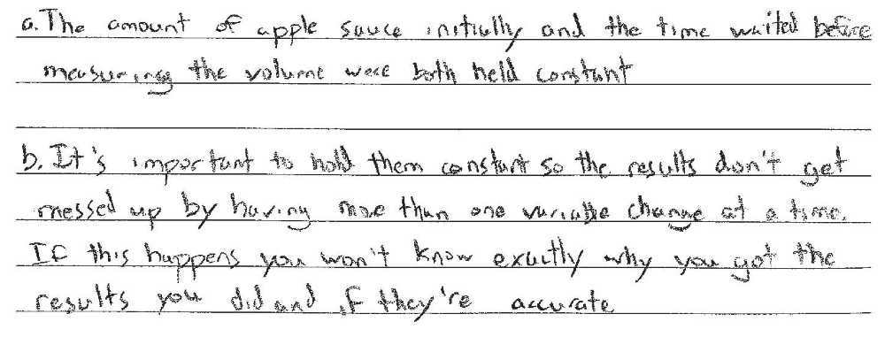

Response #2 (2)
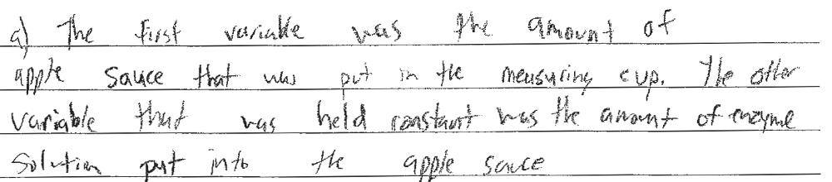
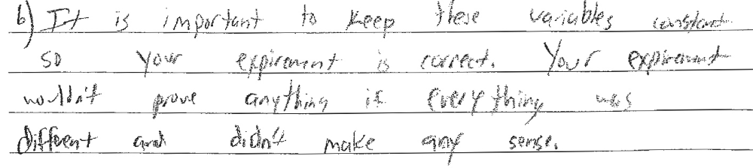

Response #3 (1)
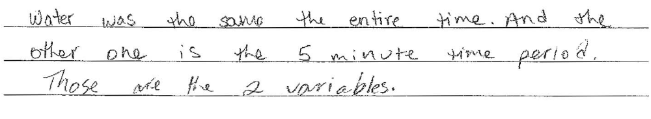

Response #4 (0)
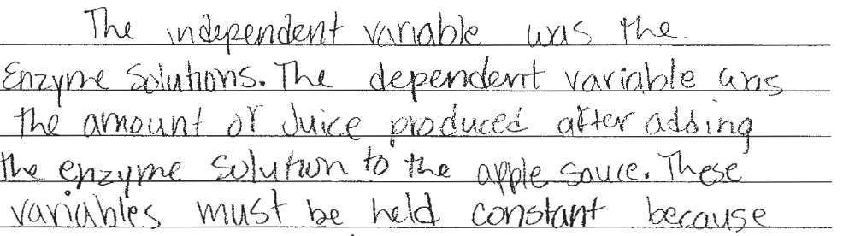
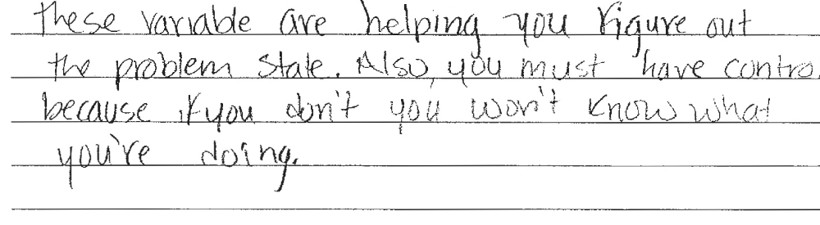

Response #5 (3)
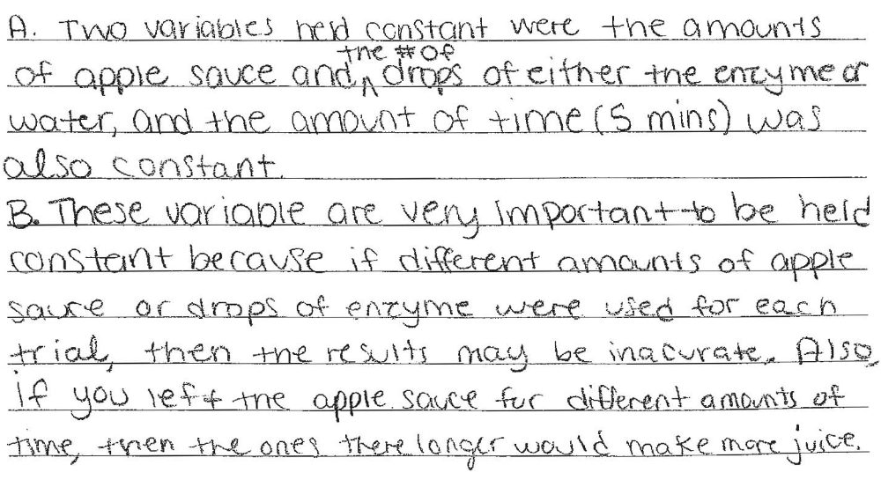

Response #6 (0)


